**Project Deployment Document: Prediction of Credit Card Fraud**

**Introduction**

This document outlines the deployment process for the Prediction of credit card fraud project, which aims to predict credit card fraud using machine learning techniques. The project follows a structured approach including data collection, exploratory data analysis (EDA), data cleaning, model selection, training, validation, and deployment.

**Project Structure**

The project is organized into the following sections:

1. Data Collection: Collect the time series data from the provided CSV file.

2. Exploratory Data Analysis (EDA): Perform data quality checks, treat missing values, outliers, etc.

3. Data Preprocessing: Get the correct data type for date, balance the data, and perform feature engineering and selection.

4. Model Development: Choose the appropriate model, split the data into train/test sets, and train the model.

5. Model Evaluation: Choose evaluation metrics, validate the model, and assess its performance.

6. Hyperparameter Tuning: Improve model performance through hyperparameter tuning.

7. Model Deployment: Plan and execute the deployment of the trained model.

1. **Tasks/Activities List**

**1. Data Collection**

Collect the time series data from the provided CSV file.

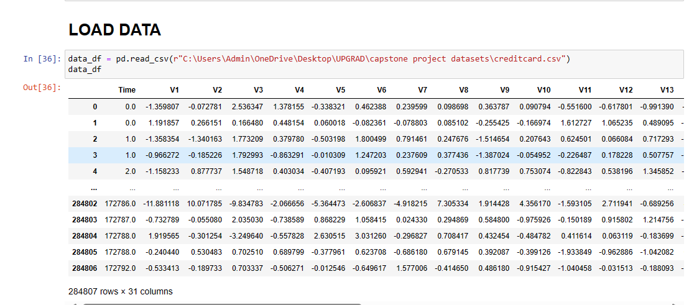

**2. Exploratory Data Analysis (EDA)**

Perform data quality checks including missing values, outliers, etc.

Visualize the data to identify patterns, relationships, and trends.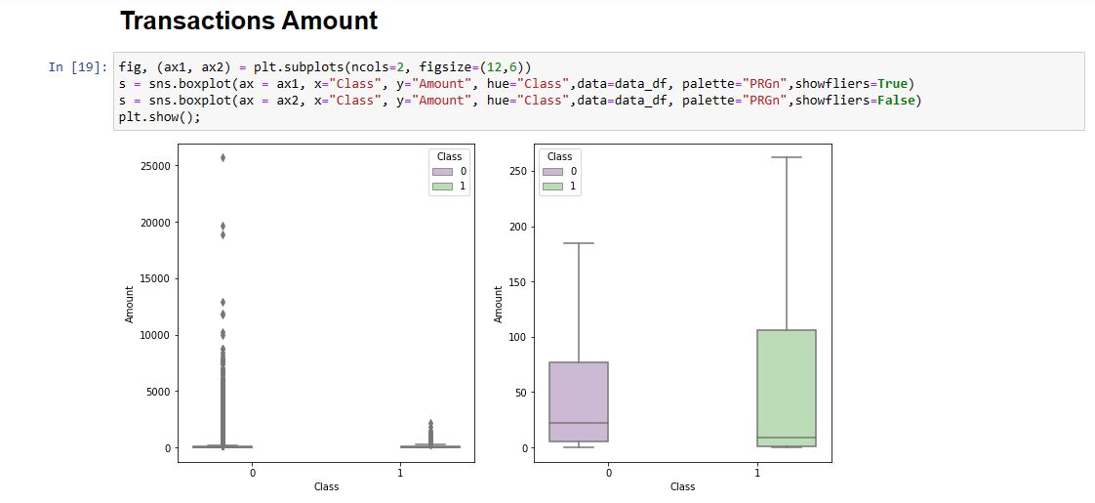

**3. Data Preprocessing**

Correct the data type for date.Balance the imbalanced data using appropriate methods.Perform feature engineering and selection for better model performance.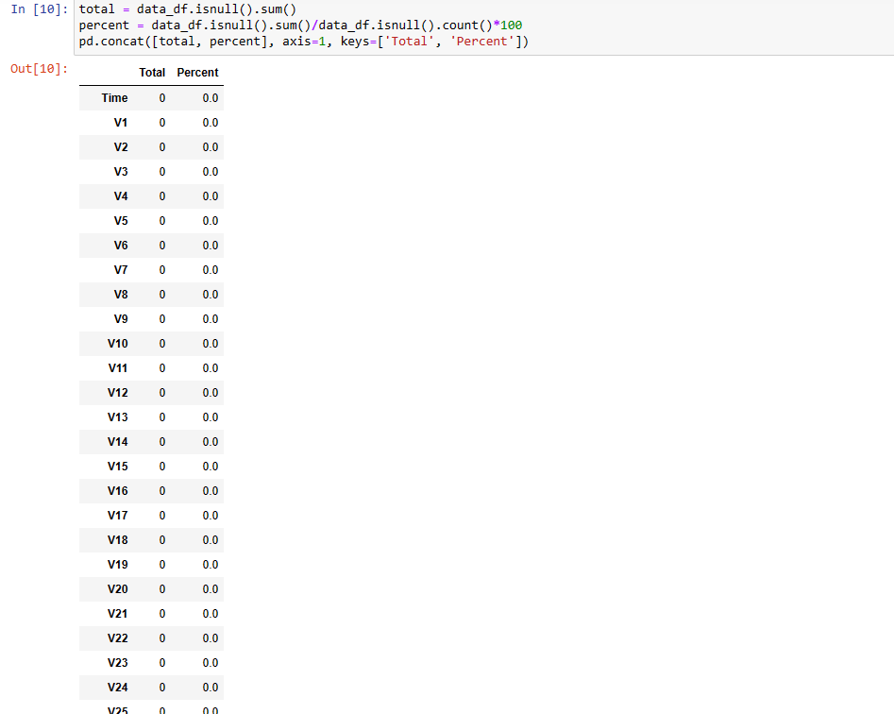

**4. Model Development**

Choose the most appropriate model for credit card fraud prediction.

Split the data into train/test sets.Train the model using the training .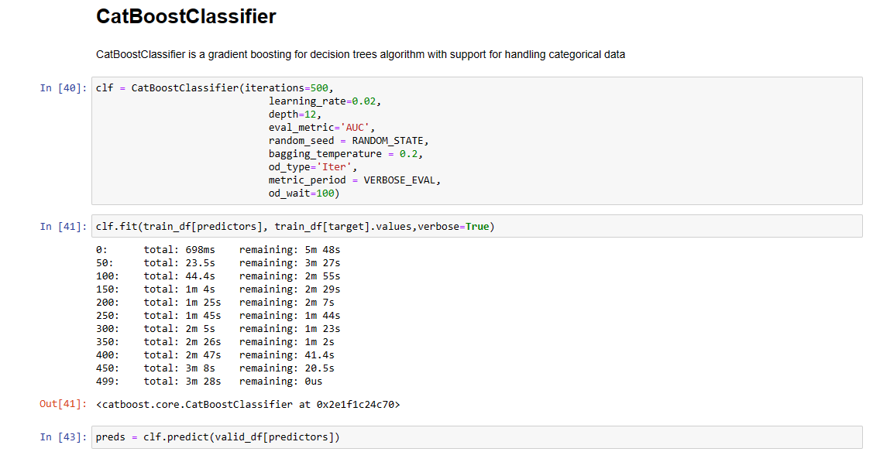

**5. Model Evaluation**

Choose evaluation metrics such as accuracy, precision, recall, and F1score.

Validate the model using the test set.Assess the model's performance and identify any issues like overfitting.

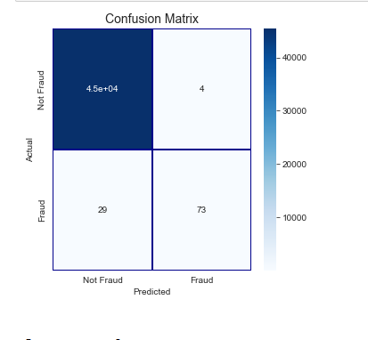

**6. Hyperparameter Tuning**

Tune the model hyperparameters to improve performance.

Implement methods for hyperparameter tuning such as grid search or random search.

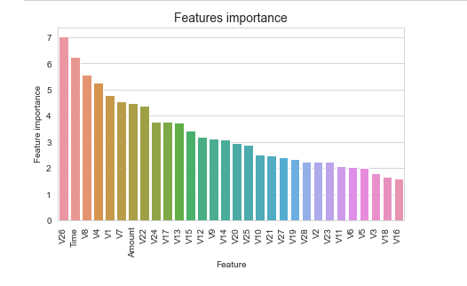

**7. Model Deployment**

Plan the deployment of the trained model.

Make the trained machine learning model available for use in a production environment.

**Success Metrics**

To ensure the successful submission of the case study, the following metrics should be achieved:

The accuracy of the model on the test dataset should be greater than 75%.

Implement methods for hyperparameter tuning to optimize model performance.

Perform model validation to estimate the model's ability to generalize to new, data.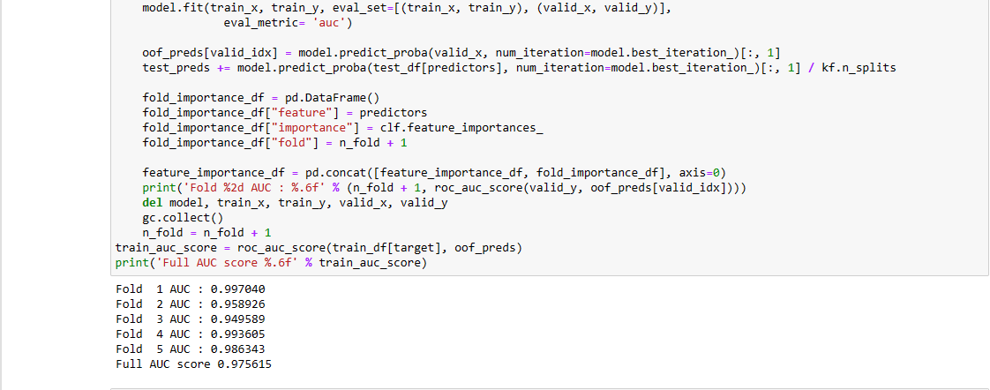

**Conclusion**

The deployment of the credit card fraud project involves a structured approach encompassing data collection, exploratory data analysis, data preprocessing, model development, evaluation, hyperparameter tuning, and deployment. By following this process and achieving the success metrics, the project aims to provide an effective solution for credit card fraud prediction.